Test case #1 (The user can browse the popular movies list)

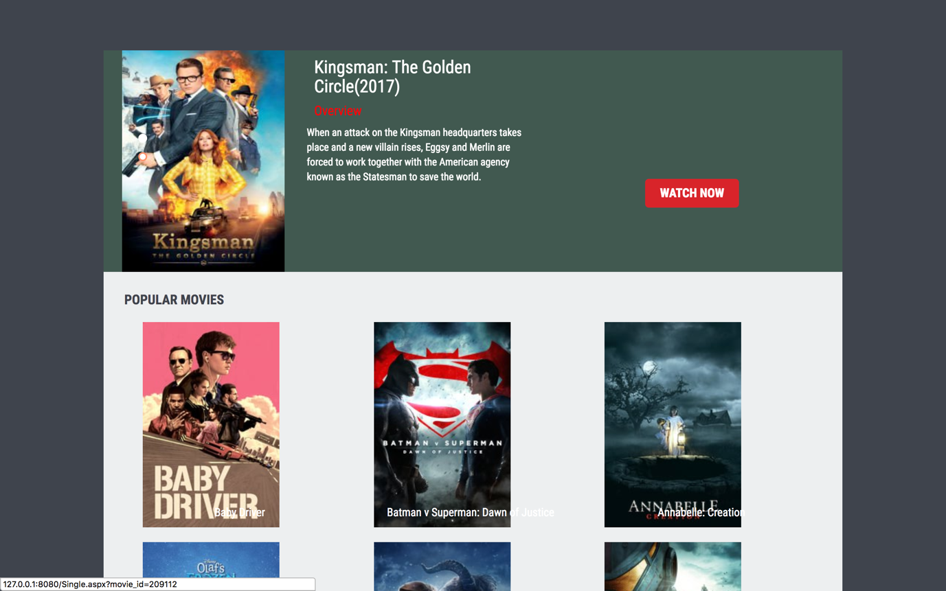

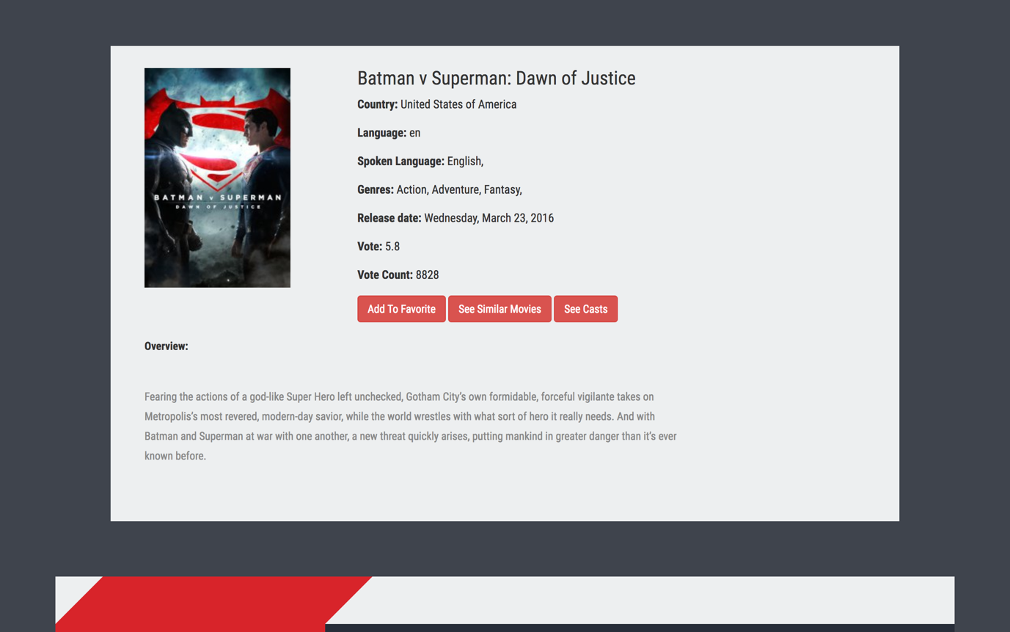

Test Case#2 (The user clicks on the favorite from the list bar on the home page)

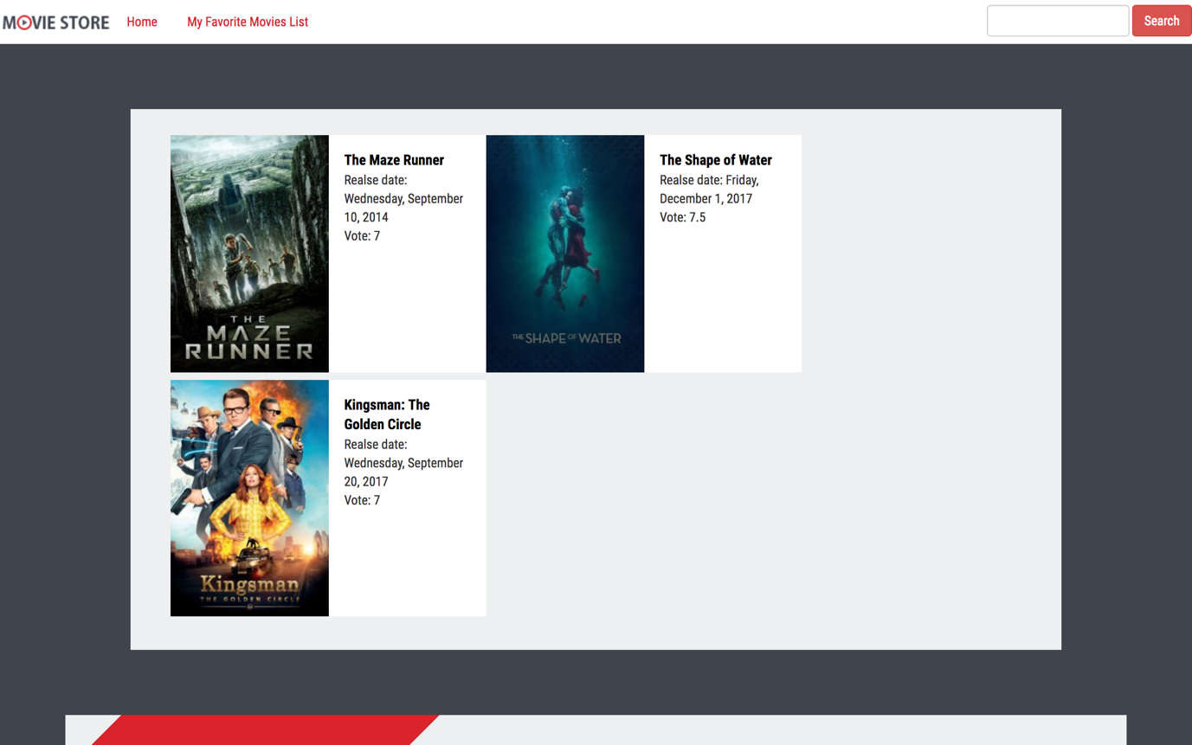

Test Case#3 (The user clicks on the add to favorite link)

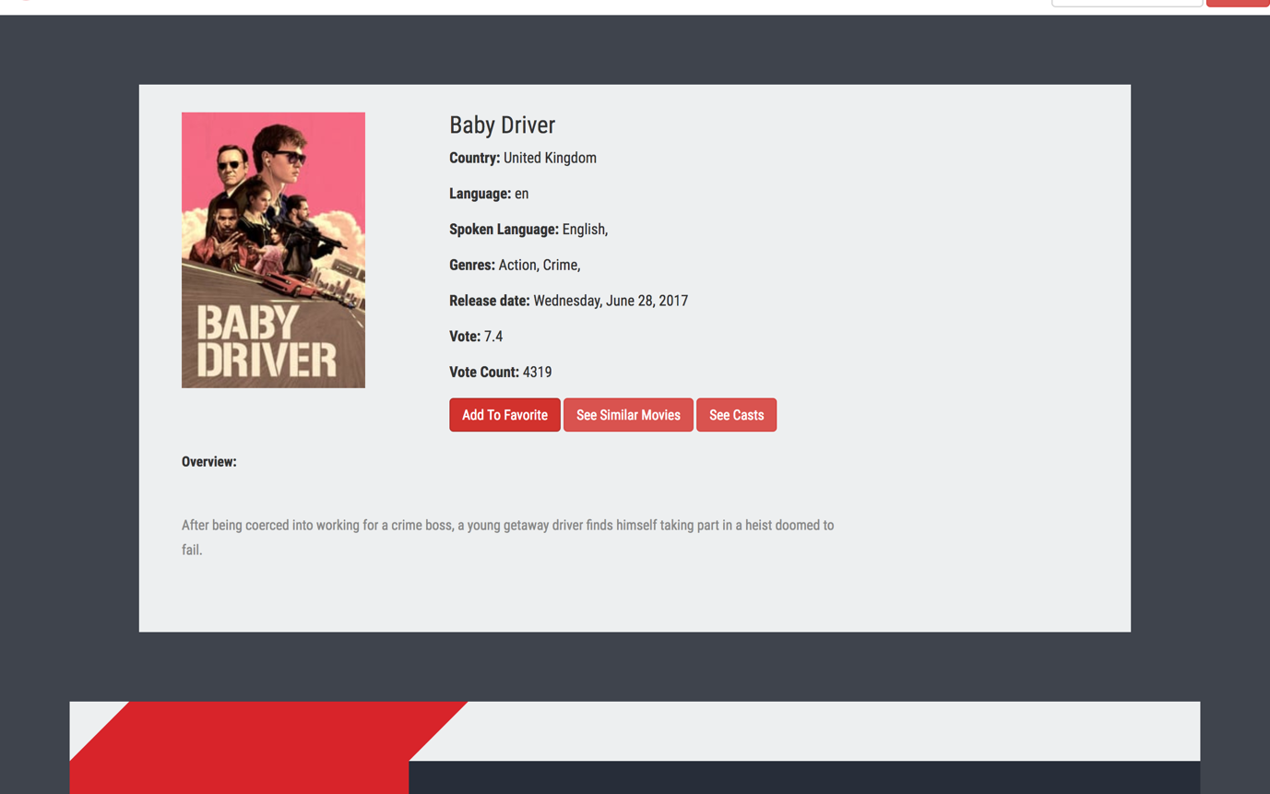

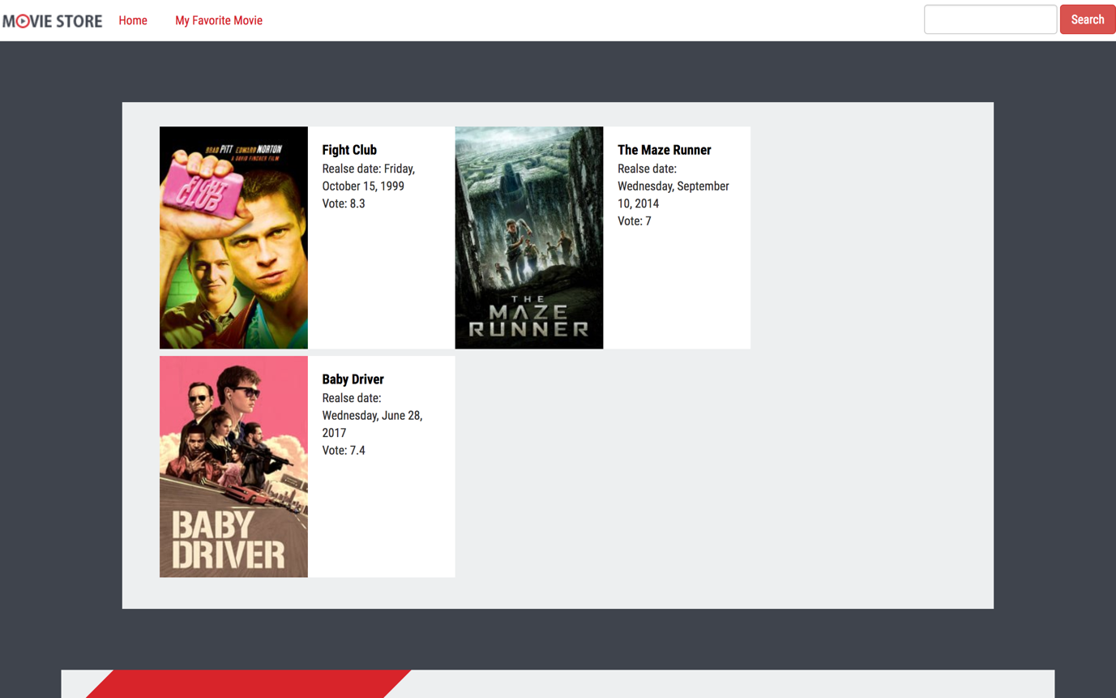

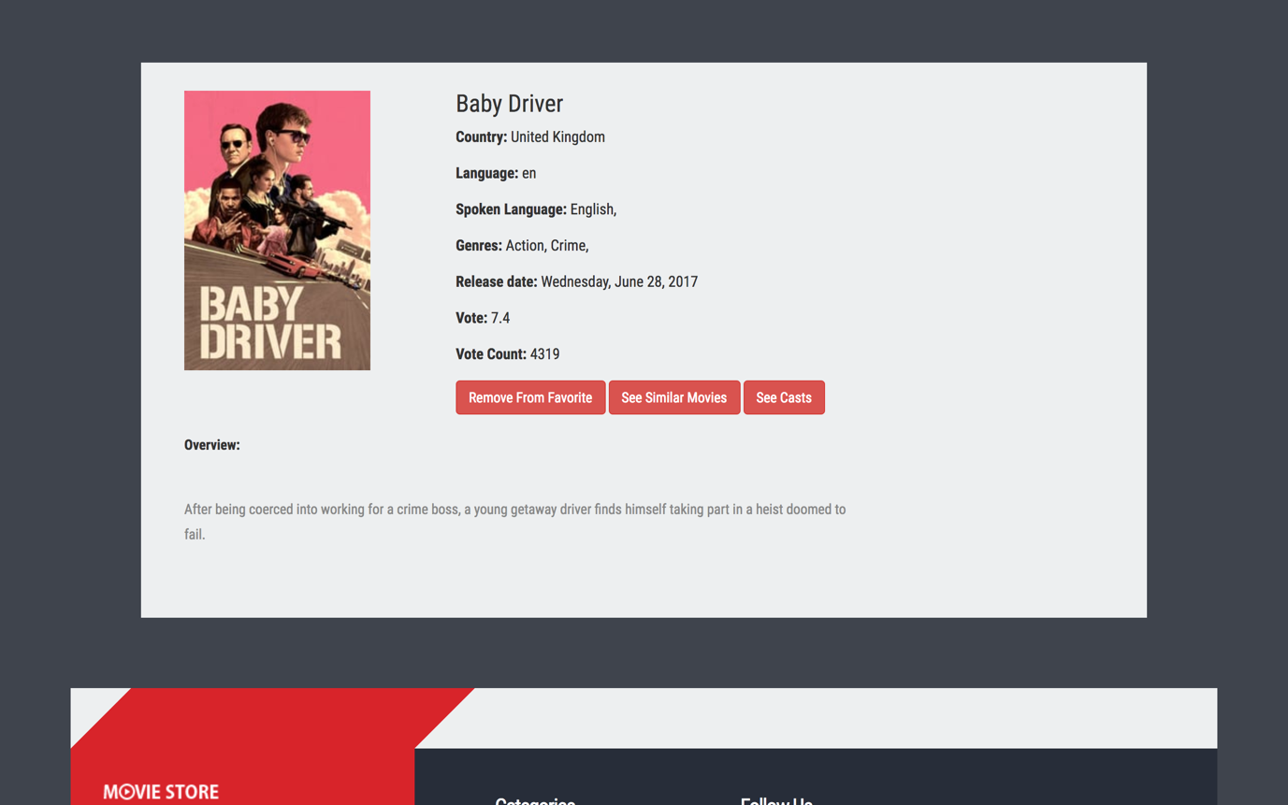

Test Case #4 (The user clicks on the remove from favorite link)

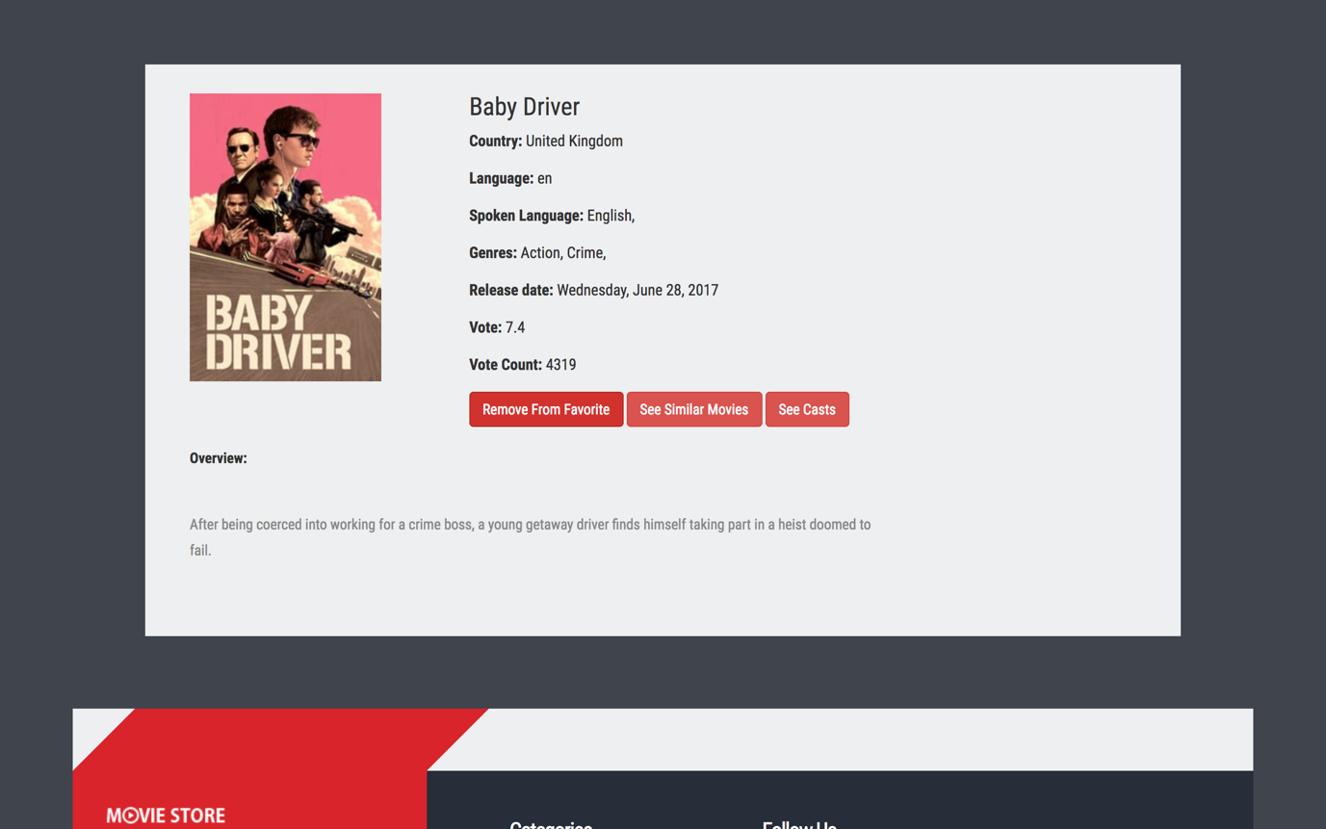

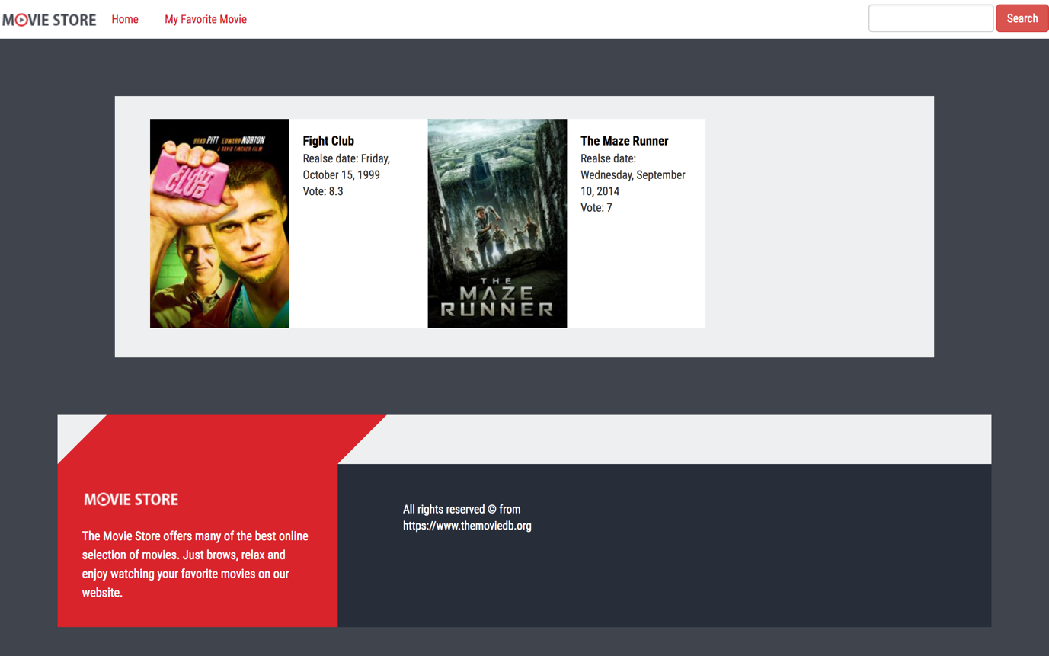

Test Case #5 (The user clicks on the GO IMDB link to go to IMDB website)

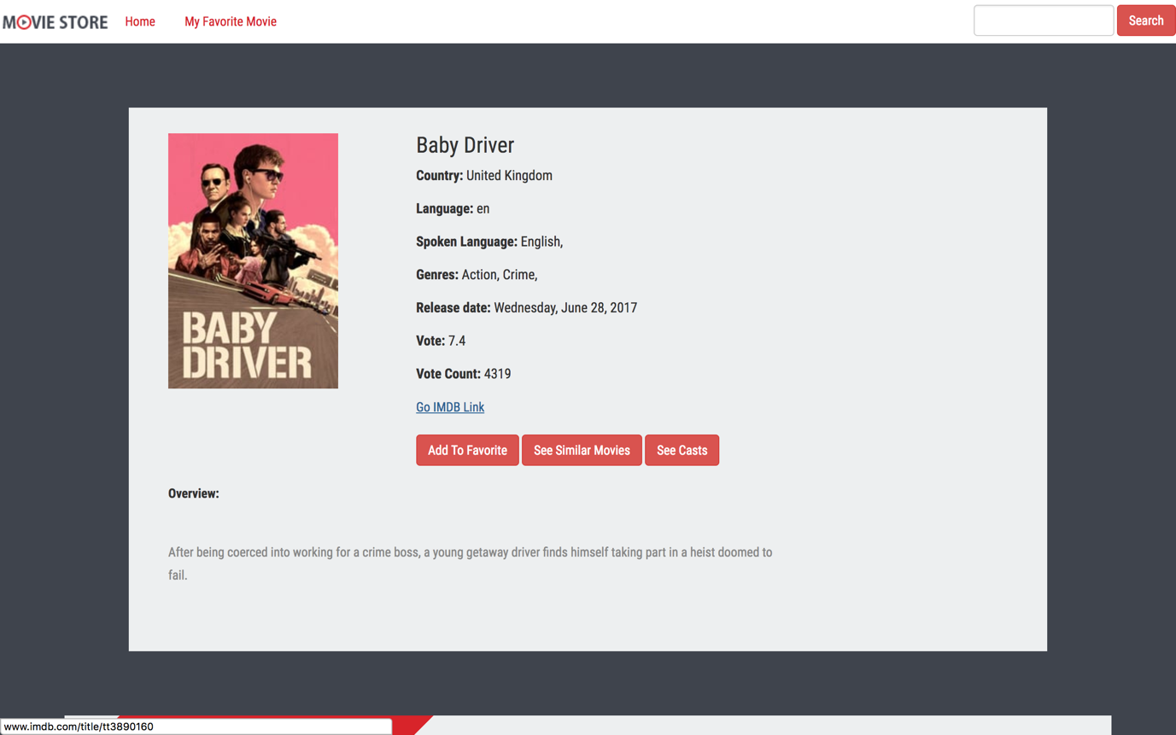

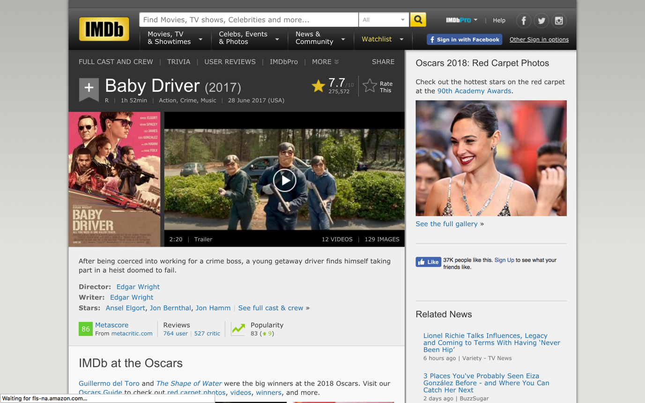

Test Case#6 (The User can see the top Billed casts on the movie)

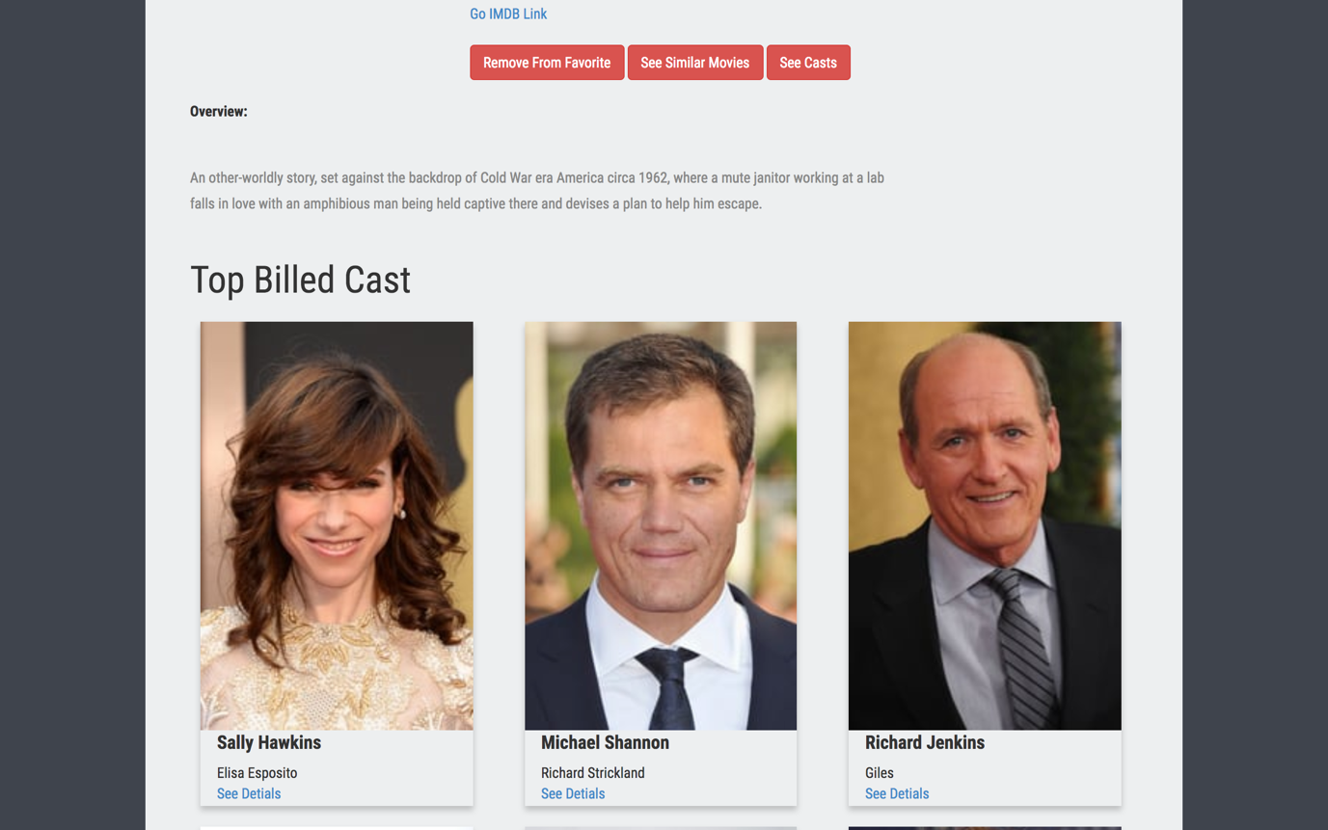

TestCase#7 (The user can see all the crew of a specific movie)

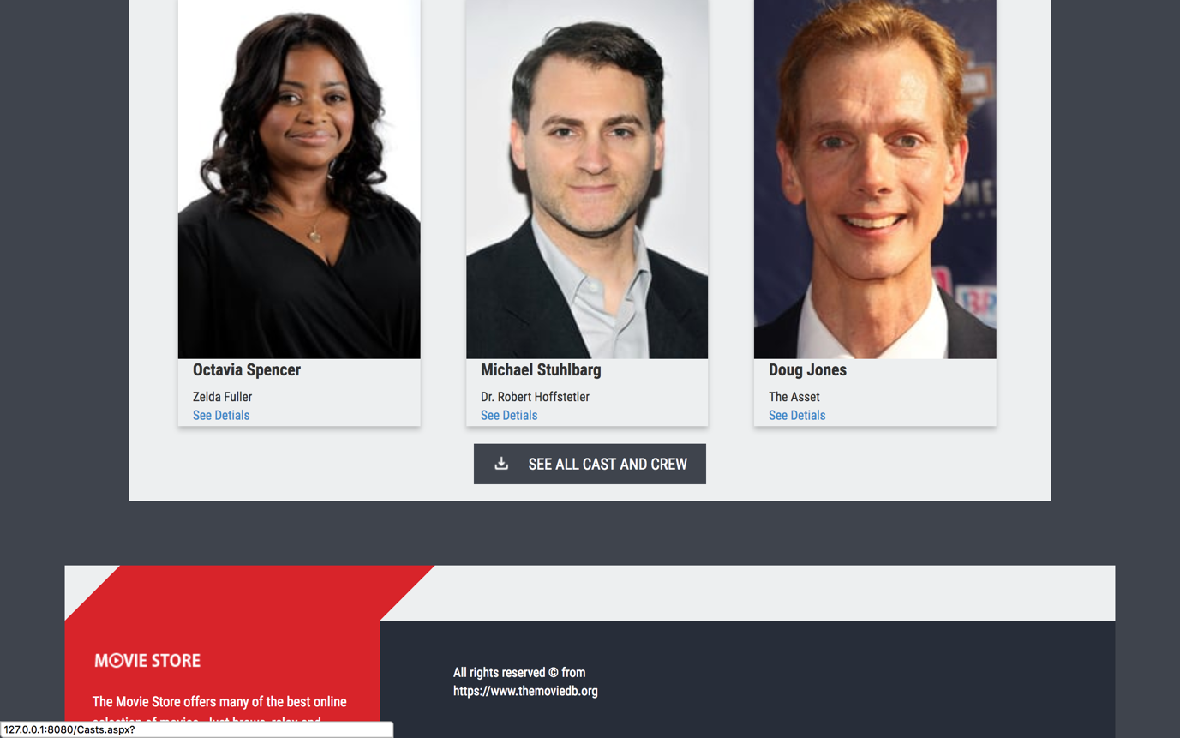

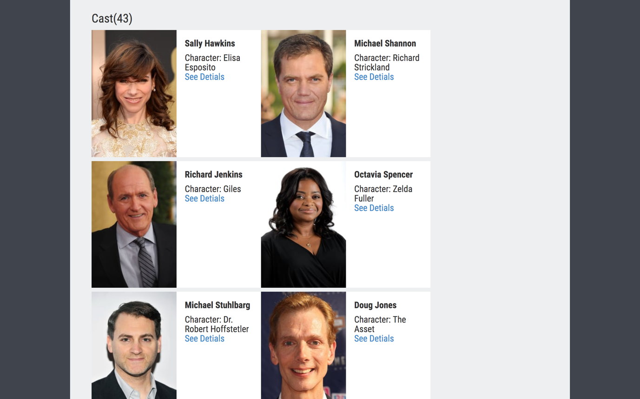

Test case#8 (The details of a specific cast is shown)

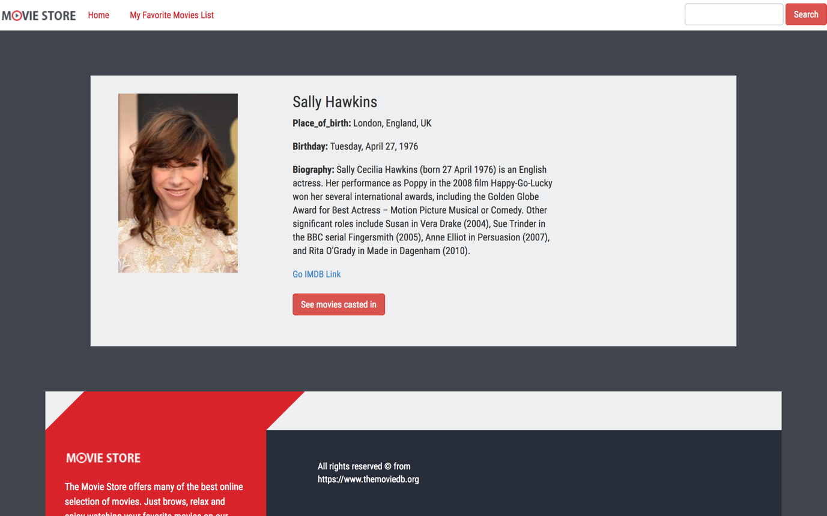

Test case#9 (The movies where a specific actor is casting in is shown)

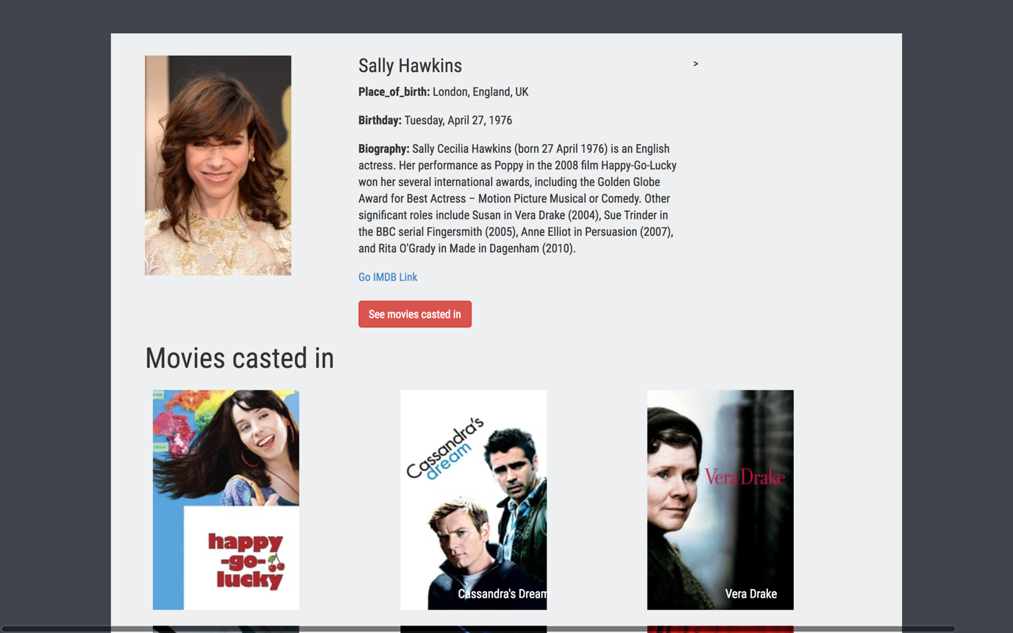

Test case #10 (The user is forwarded to the actor details page on IMDB)

